**DAILY ONLINE ACTIVITIES SUMMARY**

|  |  |  |  |  |  |  |  |  |
| --- | --- | --- | --- | --- | --- | --- | --- | --- |
| **Date:** | **05/06/2020** | | | | | **Name:** | **Shwetha** | |
| **Sem & Sec** | **8th B** | | | | | **USN:** | **4AL16CS101** | |
| **Online Test Summary** | | | | | | | | |
| **Subject** | | **BDA** | | | | | | |
| **Max. Marks** | | **30** | | **Score** | | | **15** | |
| **Certification Course Summary** | | | | | | | | |
| **Course** | **Introduction to cyber security** | | | | | | | |
| **Certificate Provider** | | | **Great learning** | | **Duration** | | | **7hr** |
| **Coding Challenges** | | | | | | | | |
| **Problem Statement:**  **Write a Python program to convert seconds to day,hour,minutes and seconds.** | | | | | | | | |
| **Status: Solved**  **Solution link: https://github.com/alvas-education-foundation/Shwetha-** | | | | | | | | |
| **Uploaded the report in Github** | | | | | **Yes** | | | |
| **If yes Repository name** | | | | | **Shwetha-** | | | |
| **Uploaded the report in slack** | | | | | **Yes** | | | |

Online Test Details:

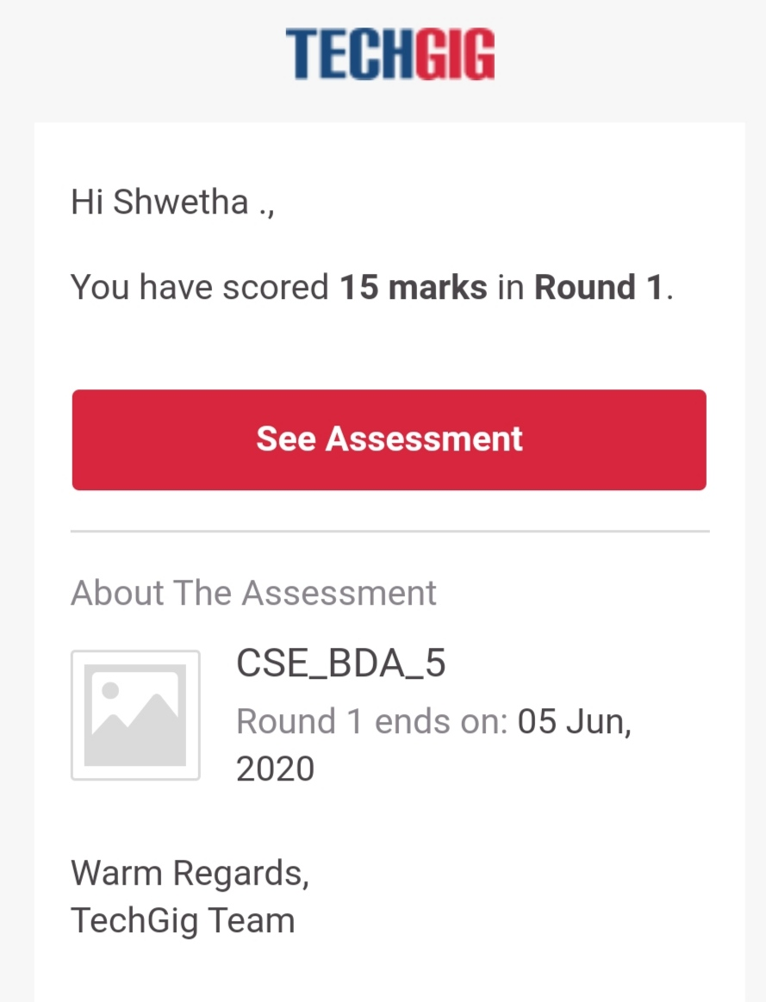

Certification Course Details:

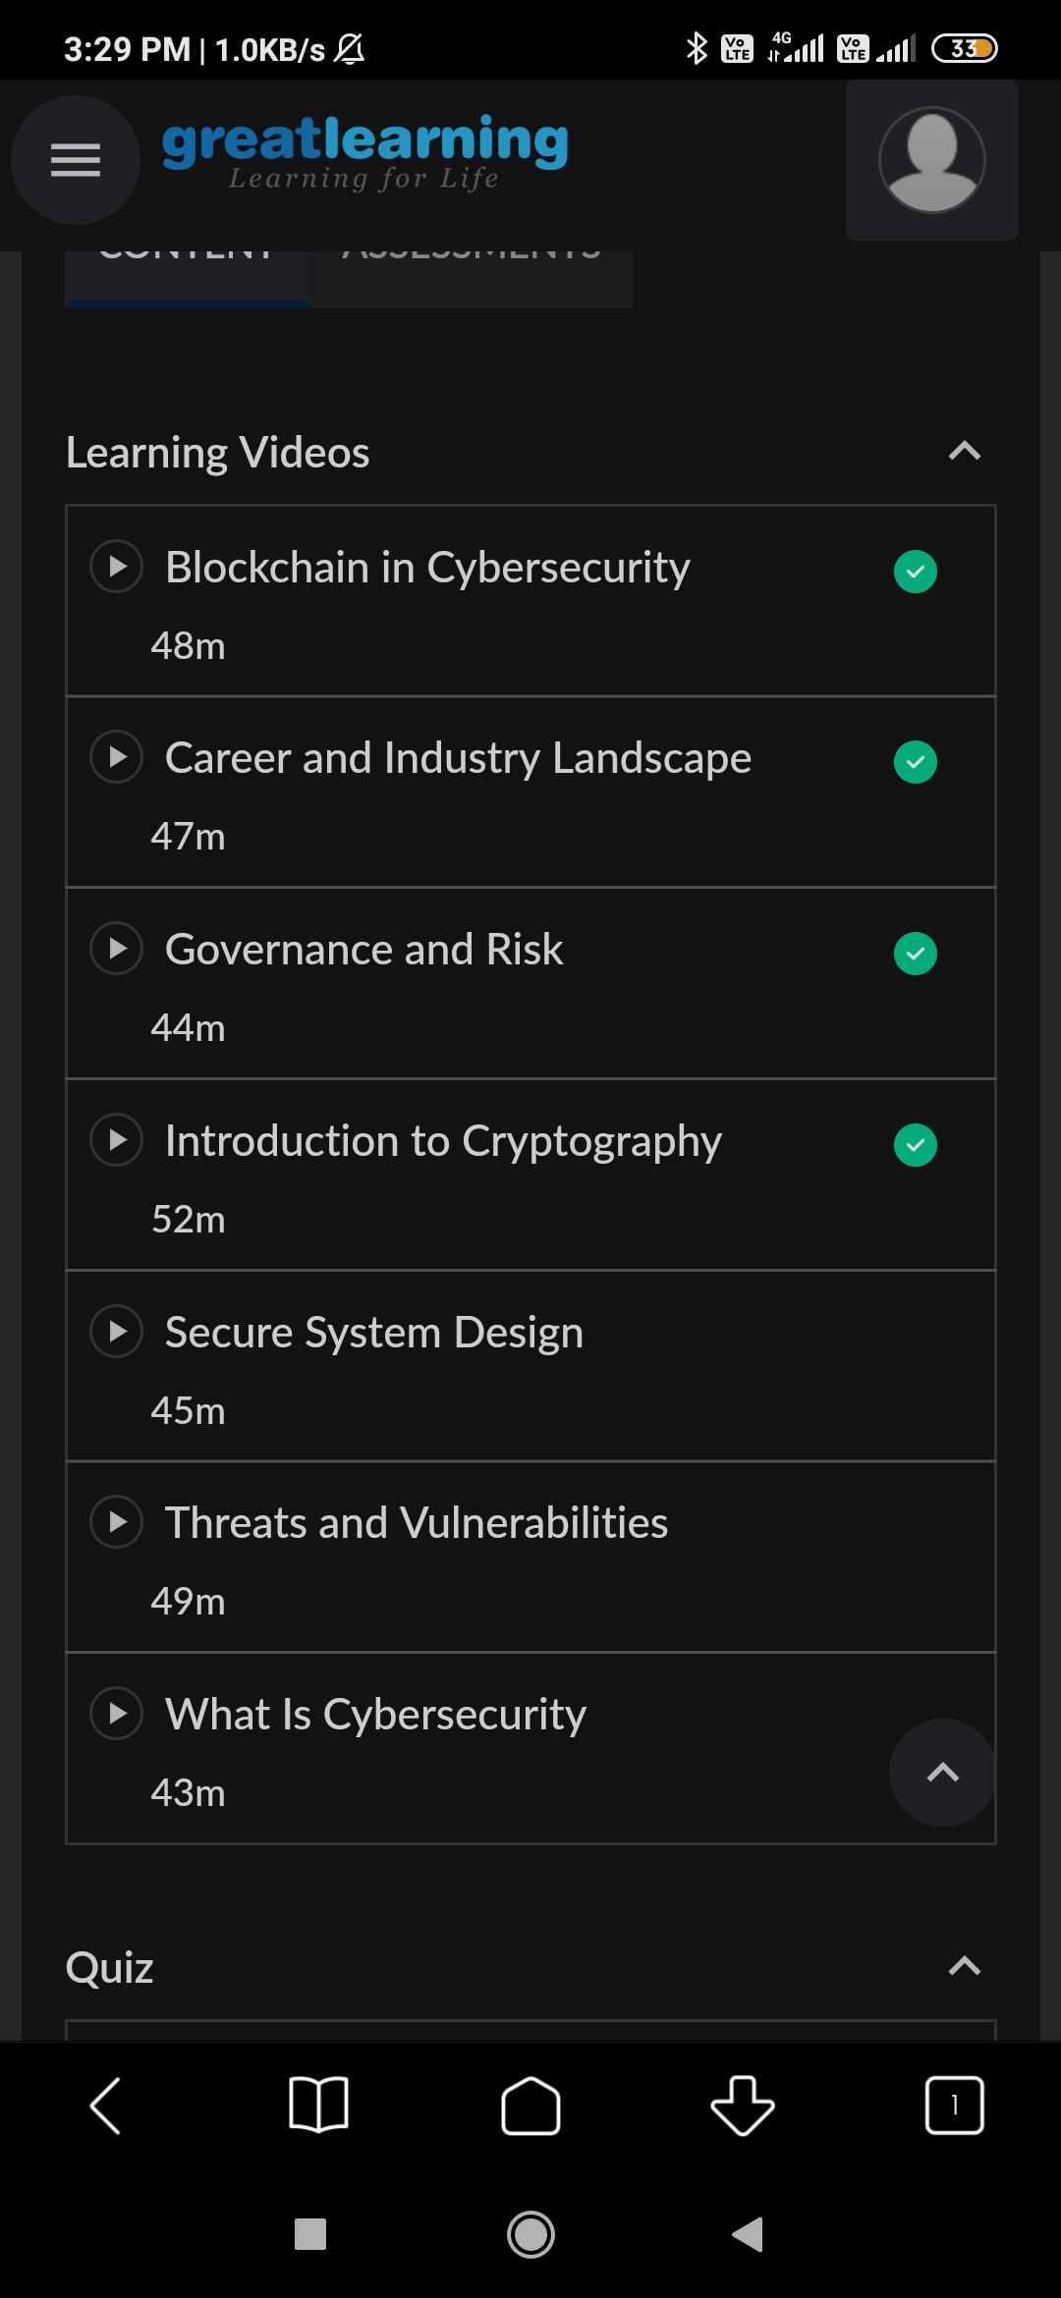

Coding Challenges Details:

time=float(input("Inputtimeinseconds:"))

day=time

//(24*3600)time=time%(24*3600)

hour=time//3600

time%=3600

minutes=time

//60time%=60

seconds=timeprint("day:->%d"%(day))

print("hour:->%d"%(hour))

print("minutes:->%d"%(minutes))

print("seconds:->%d"%(seconds))